Honest Reviews detailed informations:
Menu items: (volgorde respecteren)
- Home
- About
- Reviews
- Streams
- Donate
- Contact
- Icon of a user with arrow down to log in
->
Footer items: (onderaan elke pagina in een balk)
- Twitch icon
- youtube icon
- Paypal icon
- Twitter icon
- Facebook icon
- email icon
Review attributes that should be showed in the overview:
- Game title
- A background picture
- The score
=> (example, not binding)
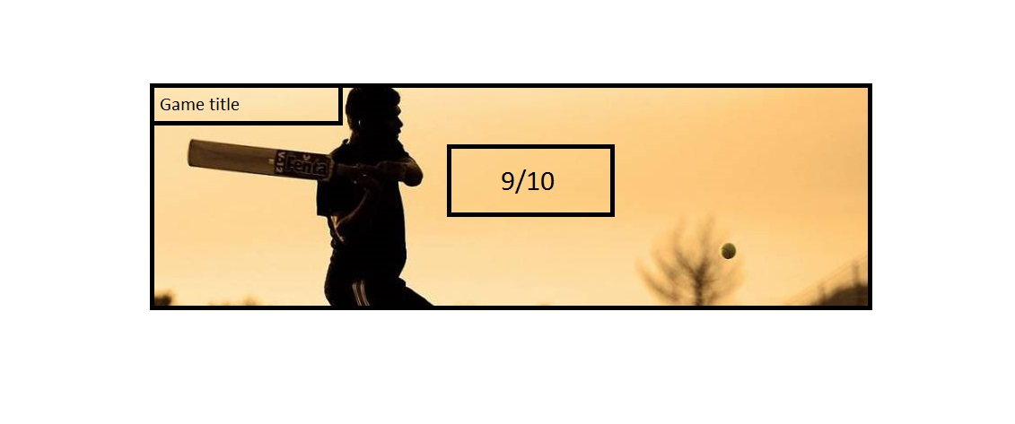
(They should come under each other )
Latest Review on home page should look the same but with a foto gallery(tumbnails) under it:
